Fly ‘Til You Die

Game Design

By Erina Caferra & Kim Coterwas

Game Design and Programming II

2/15/2018

**Game Title**: Fly ‘Til You Die

**Summary Introduction**:

We are extending the provided Flappy Bird game, a casual game. The game in its current state does not have music, so music would be added. The sound of collecting the “coins” would be changed to be a less harsh sound. As for rewards, there would be an in-game shop where the player would use the collected coins to buy either upgrades or new cosmetic skins. There will also be a personal high score list at the end of each game after the player loses or accesses it from the start screen.

A few frequently used features we will not be implementing in this game includes a worldwide leaderboard that displays other players’ personal high scores or any other online capabilities. We will not be using a complex UI system. There will also be only one form of input, a simple tap, nothing more.

We are replacing all of the in place assets and making our own. This includes sound, music, and art. There might be a possible implementation of the scenery changing as the player has a long streak through the game without dying.

**Play Rules and Mechanics**:

The rules for the game are simple: do not touch the walls and collect tokens. If the character touches a wall, the game ends. The player can progress through the game through the holes in the wall while collecting tokens. The collected tokens can later be spent to purchase upgrades for the character to improve future scores. These tokens may also be used to purchase cosmetic skins. The holes in the walls are randomly generated for the player to fly through, so no two games are alike.

**Level Design**:

The game is forever scrolling horizontally. The player is forced to go at a constant pace throughout the game.

The player must avoid obstacles that scroll across the screen by flying through the spaces between them. These obstacles are randomly generated on different parts of the screen. If the player hits an obstacle, the game will end and the player must start from the beginning again. The player will be able to collect in game currency throughout the game by hitting rewards that appear between the obstacles. As of right now, there are no enemies in the game.

Since we are starting from a preexisting game, these are screenshots from the original game:

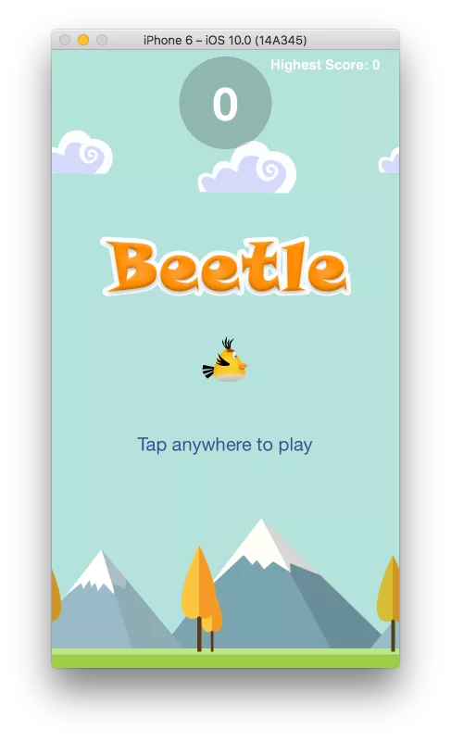

This is the standard layout of the game’s title screen. The player must tap this screen to start playing the game. This screens shows the player character and the repeating background as well as the game title.

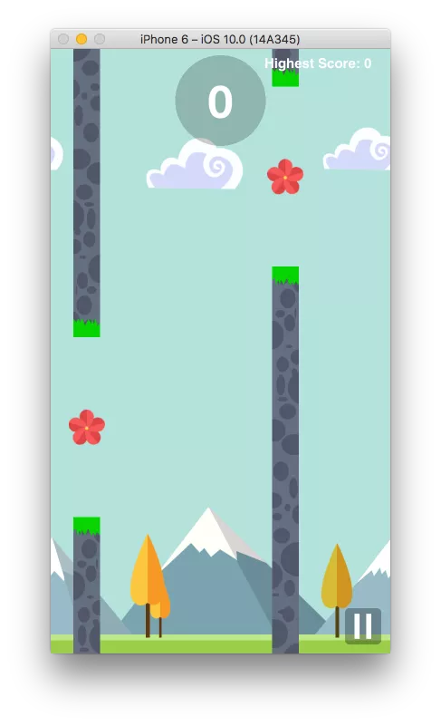

This is the the standard level layout that repeats throughout the entire game. The gray walls are the obstacles that are randomly placed and the red flowers are the token rewards the player can collect. The number at the top of the screen is the current score that the player has. There is also a pause button at the edge of the screen.

**Interaction Design:**

To interact with the game, the player can tap anywhere on the play area using the mobile device’s touch screen. Each tap moves the character up slightly, so more taps move the character up more. Not touching the screen makes the character descend which can be used as strategy to move through the holes in the walls. The player will be able to gauge how well they are doing with a score displayed at the top of the screen and a leaderboard available on the title screen as well as after the player loses. When in the shop, the player will see a brief description of the item, and can hit purchase next to the item in order to spend their collected tokens on it.

**Asset List**:

Sounds / Music:

* Flap sound - plays when the player taps the screen
  + Like the sound of a bird
* Token collect sound - plays when the player collects a token
  + Metal clinking sound
* Game over sound - plays when the player hits a wall
  + Sad descending notes
* Button interaction sound - plays when the player touches a button
  + Click noise
* Background music - plays behind the game for ambience
  + Chirpy upbeat tone

Art / Sprites:

* Bird - player character
* Walls - obstacles
* Tokens - rewards
* Buttons - navigation
* Store Items - upgrades and cosmetics
* Background - repeating / parallax

**Inspiration Board**:

Player Character:

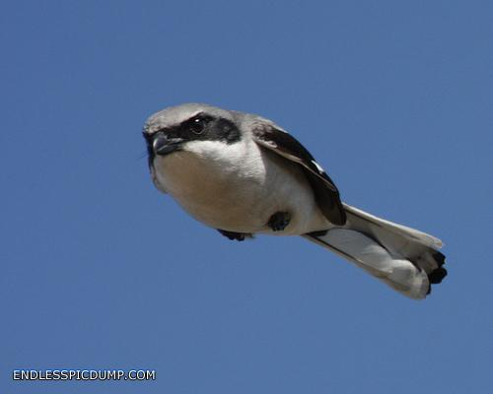

Background:

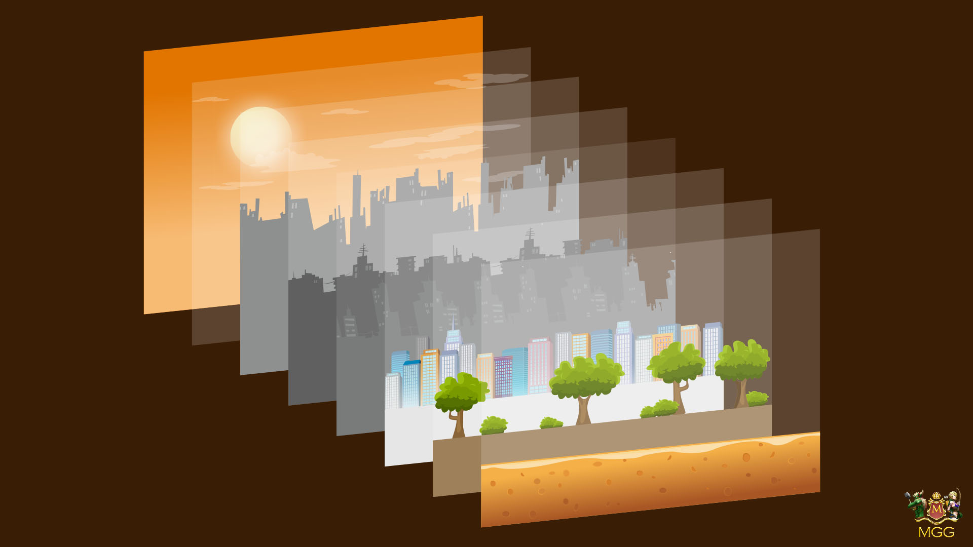

Shop:

